Chapter 7, Problem 40.

Find the capacitor voltage for t < 0 and t > 0 for each of the circuits in Fig. 7.107.

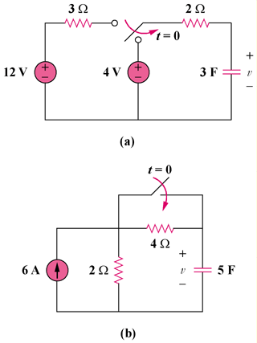

Figure 7.107
For Prob. 7.40.

